A brief history of Information Security Management (ISM) closely tracks the history of the computer itself.

The first digital computer (but not a stored-program computer) was Colossus, first used in 1943 to help the UK allied forces' war effort. It was deployed to help break ciphers used by German forces so that the allies could plan against German offensives.
The first business computing system was the LEO (Lyons Electronic Office) which was built by Lyons Bakers and first used in 1951. It helped them run payroll and was also used for stock management.
With all these systems the main user, administrator and programmer were often one and the same – meaning that technical issues could be more easily resolved and security issues – where feasible – were minimised.

Computer Security history

1965

CTSS first recorded vulnerability (OSVDB)
The text explains the very first known computer security vulnerability, which occurred in 1965 on an early time-sharing system called CTSS (Compatible Time-Sharing System).
Here’s the story in plain language:
CTSS was one of the first operating systems that allowed multiple people to interact with a single large computer at the same time.
Because many people used the system together, it introduced new security challenges.
A mistake in CTSS made it possible for users to see other people’s passwords.
This incident is considered the first recorded computer security flaw and marks the beginning of what would eventually become the computer security industry.

1967

Introducing the Network hacking
When computers started supporting timesharing and remote access, it became possible for multiple users to connect to a system from different locations.
This new capability also created new opportunities for unauthorized access.
In 1967, a group of students managed to “hack” an IBM system to gain extra features or privileges.
Gary Kildall (later famous for creating the CP/M operating system) wrote in his memoir Computer Connections about other young people gaining free access to remote PDP-10 computers.
As soon as networking was introduced—no matter how basic—it added new attack vectors, meaning new ways systems could be exploited.

1979

Kevin Mitnick hacks into DEC Ark
n 1979, a young Kevin Mitnick—who would later become one of the most famous hackers in the world—broke into a computer system owned by DEC (Digital Equipment Corporation). According to his own account in The Art of Deception, he did it because he wanted to impress a hacking gang he hoped to join.
This incident became one of the earliest high-profile hacking cases and helped shape Mitnick’s reputation.
Mitnick later became known not just for technical exploits but for mastering social engineering—tricking people rather than machines—which remains one of the most persistent and dangerous security challenges today.

1980

NYT article on NCSS breach

In 1981, The New York Times published one of the earliest mainstream news articles about a computer system breach—an incident that had actually occurred the year before. This was significant because:
1. It was one of the first times the general public heard about computer hacking.
Before this, discussions about security incidents were mostly confined to specialists, researchers, or people directly involved in computing.
2. It signaled growing public and media interest in computer security.
After this NYT article, many more stories about hacking, breaches, and computer crime began appearing throughout the 1980s. The topic was no longer niche; it entered public consciousness.
3. It highlighted the potential for notoriety in technical crime.
By putting the incident in the national media spotlight, the article demonstrated that hacking could lead to public attention, fame, or infamy—a theme that would become common in later decades as hackers gained celebrity-like status.

1981

Chaos Computer Club formed
In the same year, the first hacker 'club' was formed which would lead to more sophisticated and better-organised attacks.

1984

Reflections on trusting trust
In 1984, Ken Thompson, one of the creators of the Unix operating system, presented a seminal paper that discussed how 'back doors' could be invisibly added to systems to provide unlimited access to unauthorised users. His main question was, could we trust the creators of complex software products and systems?

1987

Christma Exec first worm - beginnings of the antivirus industry
The text recounts a major moment in the evolution of malware and the beginnings of the antivirus industry in 1987. Here’s the narrative in simple terms:
1. The first widely distributed worm appears (1987).
A program called “Christma EXEC” became the first computer worm to spread broadly.
It was written in Rexx, an IBM scripting language.
It propagated via email, copying itself across many different networks.
This made it one of the earliest and most visible examples of self-spreading malicious code.
2. Home computers face viruses at the same time.
While Christma EXEC affected networked systems, home computers had their own problems:
Boot sector viruses were spreading on systems like the Atari ST and Commodore Amiga.
These viruses often spread through infected floppy disks, a common medium at the time.
3. The first antivirus tools emerge.
To combat these threats:
The first known antivirus program, UVK (Ultimate Virus Killer), was released for the Atari in 1987.
Soon after, similar antivirus tools became available for the IBM PC, forming the early foundations of what would become the antivirus industry.
These tools would later become essential for Information Security Management (ISM) professionals.

1988

CERT created (computer emergency response team)
In 1988, the first CERT (computer emergency response team) was formed in the USA, which would go on to become a template for similar teams across the US and worldwide.
Impact:
The creation of CERT in 1988 marked the beginning of organised, professional incident response, shaping how governments and companies still handle cybersecurity emergencies today.
• It was the first formal group dedicated to responding to computer security incidents.
• Its purpose was to coordinate emergency responses, share information, and help organisations recover from cyberattacks.

1990 EFF
In 1990, the Electronic Frontier Foundation (EFF) was created. Its mission was to defend digital rights, including:
- Privacy
- Free speech
- Innovation and open technology
The EFF formed at a time when society and lawmakers were still unfamiliar with the digital world, and many early computer users and developers faced legal challenges caused by misunderstanding or fear of new technologies.

Why EFF became important
- It supported independent software developers who needed help navigating emerging digital laws.
- It also backed white hat hackers—ethical security researchers who test systems to find vulnerabilities and help organisations fix them.
- The EFF acted as a kind of protector of online freedom and an advocate for fair treatment of people working in cybersecurity.

1991

First web browser publicly available

1. The World Wide Web is created (1989)
Tim Berners-Lee, working at CERN, invented the WWW in 1989.
He created key technologies such as:
HTML (HyperText Markup Language)
HTTP (HyperText Transfer Protocol)
URLs
The first web server
This provided a new way to link and navigate information across computers.
2. The first web browser becomes publicly available (1991)
By 1991, a simple line-mode browser was released to users outside CERN.
This made the web accessible to people beyond the research community for the very first time.
3. Online activity explodes
Once the Web became public, its impact was huge:
Internet use increased rapidly
Many older or “underground” online communities—like bulletin board systems (BBSes)—moved onto the Web
As a result, these once-hidden communities became visible to far larger audiences
The Web transformed the internet from a research and hobbyist tool into a public global network.

1994
In 1994, a developer created a tool called AOHell, designed for America Online (AOL) users. At the time, AOL was one of the largest online services in the world, especially popular with beginners.

1. AOHell was a hacking toolkit for amateurs
AOHell provided an easy-to-use interface that allowed inexperienced users to perform actions normally requiring more technical knowledge, such as:
- Exploiting AOL’s systems
- Harassing or tricking other users
- Automating malicious behaviour
Because the tool did all the hard work for them, it became one of the earliest examples of a “script kiddie” toolkit.

2. It enabled the first phishing attacks
AOHell also automated one of the earliest forms of phishing, where attackers tricked AOL users into revealing:
- Passwords
- Billing information
- Personal details
These attacks were simple but effective because most people at the time were not familiar with online scams.

3. What is a script kiddie?
A script kiddie is someone who:
- Has little technical skill
- Uses tools created by others
- Launches attacks without fully understanding how they work
AOHell made it possible for such users to cause serious disruption with almost no knowledge of hacking.

1996
1. What is cryptovirology?
Cryptovirology is the idea of using malicious software (like viruses or worms) to deliver a cryptographic payload—specifically, one that encrypts the victim’s data.
In other words:
➡️ Malware that locks your files using strong encryption
➡️ And demands something in return to unlock them
This is the foundational concept behind ransomware.
2. Why the 1996 presentation was important
Before this research, malware was generally focused on destruction, disruption or replication.
The 1996 paper showed that:
Malware could use advanced cryptography
Attackers could encrypt user data in a way that couldn’t be reversed without the attacker’s private key
This could create a new kind of extortion attack
At the time, it was considered a theoretical possibility—a “proof of concept” (POC).
3. Its long-term impact
Years later, cybercriminals used the exact techniques described in the paper to create several generations of ransomware, eventually leading to:
CryptoLocker
WannaCry
NotPetya
And the modern ransomware-as-a-service ecosystem
This presentation effectively predicted one of the worst cybersecurity threats of the next few decades.

1997

1st. Information Security magazine published
Some would say that 1997 marked the formal acceptance of the Information Security discipline with the launch of an eponymously named magazine. It certainly helped bring together the disparate elements of the industry.

1998

DNSSEC proposed by ISC; IPv6 draft std.
designed to make online communication more secure and more reliable.
1. DNSSEC (Domain Name System Security Extensions)
Proposed by the Internet Systems Consortium (ISC), DNSSEC was created to make the Domain Name System more secure.
DNSSEC’s purpose:
Prevent attackers from forging DNS responses
Protect users from being redirected to malicious websites
Add authentication and integrity checking to DNS lookups
Essentially:
➡️ It adds cryptographic verification to DNS to ensure “this website is really the website you think it is.”
2. IPv6 (Internet Protocol version 6)
The IPv6 draft standard was also published in 1998, aiming to fix limitations of IPv4.
Its goals included:
Vastly increasing address space
Improving security with built-in support for IPsec
Enhancing routing efficiency
Preparing the internet for long-term growth
IPv6 was designed to replace IPv4 and secure communications at the network level.
3. The important takeaway
Although these technologies were introduced over 20 years ago, adoption has been slow:
DNSSEC is still not widely used by many domain owners or ISPs
IPv6 adoption has grown but remains far from universal—many networks still rely heavily on IPv4
So the lesson is:
➡️ Even essential security technologies can take decades to become mainstream.
➡️ And sometimes, they never become widely adopted at all.

1999

Melissa virus released – first mass emailer
In 1999, the Melissa virus became the first Windows PC virus to cause major economic damage worldwide. It marked a turning point in the history of malware because it spread extremely quickly and disrupted businesses on a global scale.

1. What Melissa was
Melissa was a mass-mailing macro virus that infected Microsoft Word documents. When someone opened an infected file:
- It activated a malicious macro
- It used Microsoft Outlook to email itself to the first 50 contacts in the user’s address book
- This caused huge amounts of email traffic and overloaded mail servers

2. Why Melissa mattered
Before Melissa, many viruses were inconvenient or mostly hobbyist creations. Melissa was different because it:
- Spread rapidly through corporate networks
- Crashed or overloaded email systems
- Disrupted business operations
- Required expensive cleanup and downtime
This was one of the first times businesses realised that malware could cause real financial losses, not just annoyance.

3. Impact on cybersecurity
The Melissa incident:
- Triggered widespread corporate security reviews
- Led businesses to rethink email and macro security
- Prompted Microsoft to introduce stronger macro protections
- Raised awareness of social engineering, because Melissa relied on users trusting an attachment that looked harmless
It also helped establish mass-mailing malware as a serious threat, paving the way for later worms like ILOVEYOU and Anna Kournikova.

2000

Y2K – millennium bug
1. What Y2K was
For decades, many computer systems stored the year using two digits (e.g., “99” for 1999).
The worry was that computers would interpret “00” as 1900 instead of 2000, potentially causing:
- Software failures
- Date miscalculations
- System crashes
- Infrastructure problems (e.g., power, banking, healthcare)
This created global concern about what would happen when the date rolled over on 1 January 2000.
Summary of the story
The Y2K bug became a major milestone in IT history:
- It created massive global concern
- It drove one of the largest coordinated software maintenance efforts ever
- It ultimately caused fewer issues than expected
- It still sparked debates about preparedness vs. hype
- And it produced several smaller but real incidents that reminded the world of how fragile digital systems can be

2001

NCSA (national cyber security alliance) form
In 2001, the National Cyber Security Alliance (NCSA) was created in the United States.
This organisation focuses on helping everyday computer users, including:
- Consumers
- Small businesses
- Schools and families
The purpose of the NCSA is to provide practical, easy-to-understand advice on:
- Online safety
- Cybersecurity best practices
- Safe internet behaviour
- Protection against common threats such as scams, malware, and identity theft

Why it matters
At a time when the internet was rapidly expanding into homes and businesses, most people had little understanding of cybersecurity risks. The NCSA filled an important gap by:
- Raising public awareness
- Running nationwide safety campaigns (e.g., what would become Cybersecurity Awareness Month)
- Offering free resources and guidance
- Supporting smaller organisations that lacked their own security expertise
It helped make cybersecurity a mainstream concern, not just something for technical professionals.

2002

MS Trustworthy Computing Initiative
In 2002, Microsoft launched a major internal reform called the Trustworthy Computing Initiative. This was a landmark moment in the company’s history because it fundamentally changed how Microsoft approached security, privacy, and reliability in its software.

1. Why Microsoft created the initiative
In the late 1990s and early 2000s, Microsoft faced heavy criticism for security weaknesses in the Windows 9x product line (Windows 95, 98, Me). These systems were:
- Not designed with strong security in mind
- Frequently targeted by malware
- Lacking proper protection for network-connected environments
- Increasingly seen as a weak spot in business and home computing
High-profile viruses like Melissa (1999) and ILOVEYOU (2000) highlighted these vulnerabilities even more.

2. What Microsoft did in 2002
Microsoft’s CEO at the time, Bill Gates, sent a famous internal memo declaring that security must become the company’s top priority. This memo launched the Trustworthy Computing Initiative.
Under the initiative, Microsoft:
- Re-trained tens of thousands of engineers in secure coding practices
- Paused development on Windows to conduct a massive security review
- Introduced formal security development processes
- Improved default security settings
- Increased investment in patching, updates, and vulnerability management
This was one of the largest security-focused transformations in the software industry.

3. What the initiative led to
The Trustworthy Computing approach resulted in:
- Windows XP Service Pack 2, a major security overhaul
- The introduction of Windows Firewall, DEP (Data Execution Prevention), and other protections
- More secure future versions of Windows (Vista, 7, 8, 10…)
- Stronger security built into Microsoft Office products
- The creation of Microsoft’s Security Development Lifecycle (SDL), now a model for the entire software industry
It marked a shift from “add security later” to “design security from the start.”

2003

First botnets in wide use (MaxITE Script)
In 2003, the cybersecurity world witnessed one of the first large-scale, coordinated botnet operations. These early botnets were built using a scripting framework known as MaxITE Script, and they relied heavily on IRC (Internet Relay Chat) for communication and control.

1. Early botnets used IRC for Command & Control (C&C)
At that time, IRC was a popular messaging protocol, and attackers realised they could use it to remotely control thousands of infected machines.
They used a specific IRC extension called XDDC (eXtended Direct Client Connection), which made it easy to:
- Issue commands to all infected computers
- Coordinate attacks
- Transfer files
- Maintain persistent control
This was one of the first moments attackers used real-time, synchronised C&C channels for cybercrime operations.

2. What these botnets did
These early botnets were often used to:
- Launch distributed denial-of-service (DDoS) attacks
- Spread worms
- Distribute spam
- Steal credentials
- Perform automated reconnaissance
For the first time, large numbers of compromised PCs could be centrally controlled like an army.

3. Start of a new era in cyber threats
The MaxITE Script–based botnets were only the beginning. Over the next 15 years, attackers would develop many different scripts, malware families, and C&C protocols, such as:
- Agobot / Gaobot
- SDBot / RBot
- Zeus
- Conficker
- Mirai
- HTTP-based and P2P botnets
These evolved into the highly sophisticated botnet ecosystems we know today, including those rented through botnet-as-a-service.

2007

Cyberterrorism attacks begin (Estonia)
The text describes the 2007 cyberattacks against Estonia, widely recognised as the first large-scale example of state-level cyberterrorism or cyberwarfare. These attacks marked a turning point in global cybersecurity.

1. What happened in Estonia (2007)
In April–May 2007, Estonia experienced massive, coordinated cyberattacks targeting:
- Government websites
- Banks
- News outlets
- Emergency services
- Telecommunications
The attacks used:
- Botnets to launch large DDoS waves
- Website defacement
- Flooding of network infrastructure
They effectively shut down or severely disrupted national digital services for days. It was one of the first times a country experienced such widespread digital disruption on a national scale.

2. Why it matters
This event is widely considered the first major instance of cyberterrorism or state-backed cyber aggression. It showed:
- How one country could target another entirely through online means
- How critical national infrastructure could be disrupted without physical violence
- How cyberattacks could become part of geopolitical conflicts
It was a moment when the world realised cyberwarfare had moved from theory to reality.

3. Aftermath: a new era of cyberattacks
The passage then explains that after 2007, cyberattacks using the methods already discussed (botnets, viruses, worms, phishing, etc.) became extremely common. There were so many incidents that listing all of them would take an entire module on its own.
Examples include:
- Stuxnet (2010)
- The attacks on Georgia (2008)
- Sony Pictures hack (2014)
- WannaCry (2017)
- NotPetya (2017)
- Many more analysed by CERT teams globally

4. CERTs and the rise of professional cybersecurity teams
The final point is that the enormous rise in cyberattacks made it clear that organisations and governments must have:
- Dedicated cybersecurity teams
- Incident response experts
- Monitoring and mitigation capabilities
Cybersecurity went from being optional or secondary to being essential.

Brief History:1943 (decipher in world war II), 1965 (an operating system that allowed multiple users interactive access to a central computer system), 1967 (hacking IBM system-getting access by some students to remote PDP-10), 1979 (Kevin Mitnich first hacker into )

Concepts of Information Security Management

CIA (+N)
–
The main concepts that underpin Information Security Management – the so called 'three tenets of security' (Campbell, 2016) are Confidentiality, Integrity, and Availability. Increasingly many sources also add Non-repudiation to that list.

Confidentiality is defined by ISO/IEC 27000:2012 as where “Information is not made available or disclosed to unauthorized individuals and entities or processes.” (Campbell, 2016). Integrity is defined in that same standard (ISO/IEC 27000:2012) as “the property of accuracy and completeness of assets.” (Campbell, 2016).

ISO/IEC 27000:2012 defines availability as “the property of being accessible and usable upon demand by an authorized entity.” (Campbell, 2016).

Finally, that same standard defines non-repudiation as the “ability to prove the occurrence of a claimed event or action and its originating entities.” (Campbell, 2016). All of these principles will be discussed in more detail in later sections.

Threats and Vulnerabilities
–
Additional important principles include threats and vulnerabilities. ISO/IEC 27000:2012 defines a threat as “the potential cause of an unwanted incident, which may result in harm to a system or organization.” That same standard defines a vulnerability as “a weakness of an asset or control that can be exploited by one or more threats.” (Campbell, 2016).

The importance of any threat or vulnerability is very much dependent on the probability of it occurring – hence both are closely related to risk assessment processes – and a specific example of such a process is commonly referred to as threat modelling. All of these will be discussed in more detail in subsequent sections.

Information Security Management Roles
–
The information discussed so far clearly shows that the information security professional role is multifaceted – accordingly entry routes into the profession are varied and a number of these will be discussed in subsequent sections as well.

CIA
As discussed in the course text, information security management can be viewed as a discipline that manages "people, process(es) and technology," (Campbell, 2016). In this section, we will look at each of the core concepts in turn and what should be put in place in terms of managing the above.
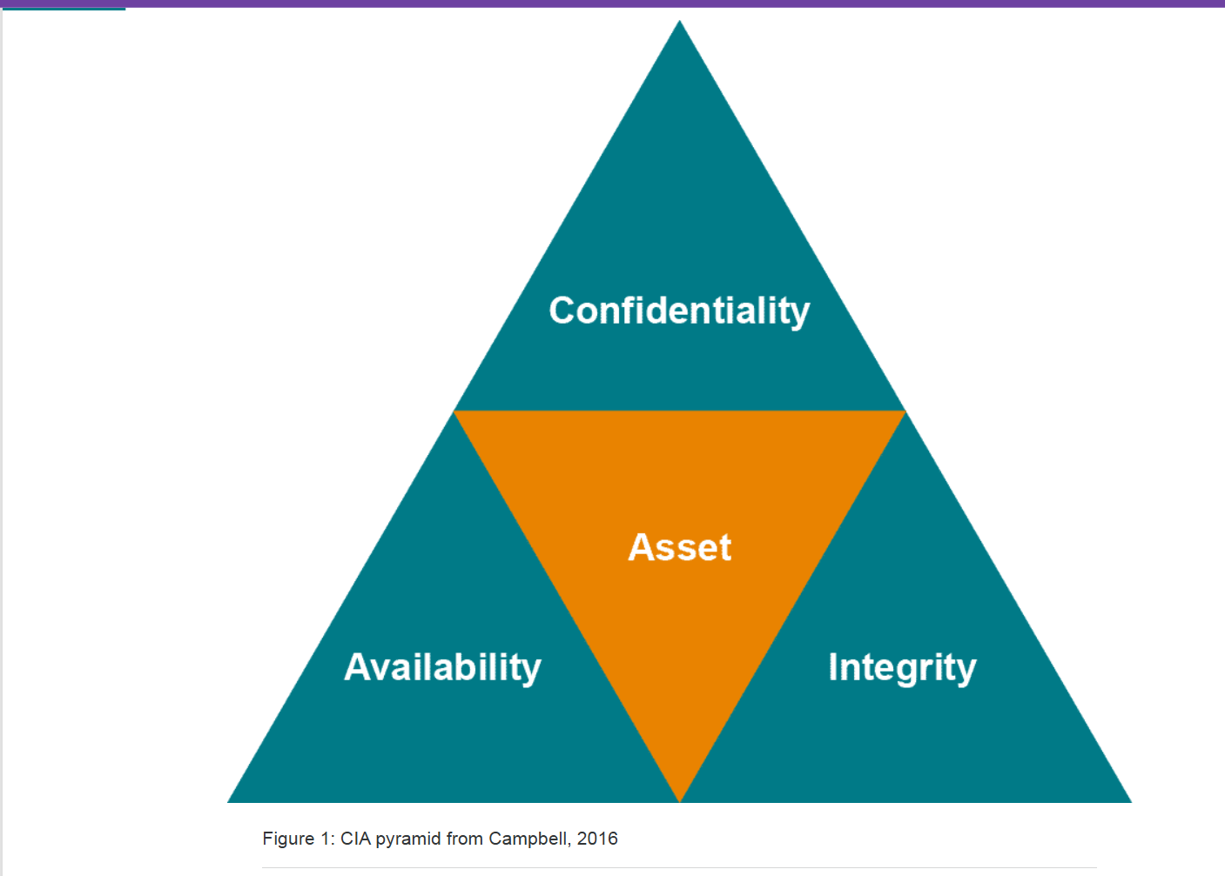

Confidentiality
To maintain confidentiality we need to ensure that we have correct and robust processes that clearly and unambiguously inform users of their responsibilities in handling and managing data. The first requirement is to be clear on the level of confidentiality required for each piece of data.
The UK Government has a set of classifications that each asset falls into, and that clearly defines the level of confidentiality and how that asset should be treated to comply with the classification.
Since 2014 the UK Government has simplified the previous classification system – there are now only three categories –
- Official
- Secret
- Top Secret
- (UK.GOV, 2013)
The vast majority of documents will be classified as Official, whereas only assets that could cause major military, commercial or international issues would be classified higher. The same security products and systems may be used to manage all three categories, with enhanced settings or processes employed for the higher security category items. For example, the processes in place may define what assets can be sent via email, who they can be sent to (I.e. within the Government network or outside it) and what controls should be applied. People should be trained to understand what each category refers to, and how assets in each category should be managed.
The technology aspect of confidentiality involves how security tools can be used to enforce the classification of an asset. For example, cryptographic software can be set to automatically encrypt any email attachments or rules on an email server can check headers (or even addresses in the TO: field) and enforce the rules around the transmission of data.
Many modern anti-virus suites have a DLP (data loss prevention) product that provides some or all of the above functionality as well as managing physical devices (for example preventing USB memory sticks from being accessed, or enforcing automatic encryption of removable media).

On the local network (LAN) standard network operating system functionality ensures that no unauthorised user is allowed access through the use of authentication and authorisation mechanisms such as usernames, passwords and increasingly two-factor authentication mechanisms. These technologies will be discussed in more detail in a later session in this module.
Despite the use of the best processes and technologies available, the human element is always the weakest link in any security chain. It may be through malicious intent (such as exhibited by disgruntled employees) or through ignorance (a lack of training and/ or understanding) but many confidentiality leaks are due to the human factor.
There are numerous examples – Kevin Mitnick and his well-publicised use of 'social engineering' to get passwords and even usernames from naive users, or it may be examples such as Hillary Clinton using personal email servers to transmit Government emails. Whatever the instance, these kinds of human errors cannot be stopped by technology – they require training and user briefing sessions.

Integrity

If we consider integrity, the challenge is to ensure that an asset is not changed by an unauthorised person or in an unauthorised way.

From a process perspective, it requires that editing processes are well defined and documented and that authors, reviewers and editors are aware that any changes must be logged and managed so that an audit trail is available.

Technology can be a huge help in these situations – most modern assets are maintained in some form of a version-controlled repository. Modern tools like SharePoint maintain a version history of a document so that an audit trail of changes is easily available – and unauthorised changes can easily be reversed. In addition, the audit trail will keep a history of who made the changes – illustrating the importance of managing your own password and login information.

Tools such as track changes in modern document processing tools make the review and editing process easier to manage as well. Keeping only one instance of a document – and sharing a link to that – also reduces problems caused by multiple, uncontrolled versions.
In this case, the technology tools available do make it easier to manage the human factor – version control makes 'accidental' changes easy to reverse and malicious changes easy to track and manage as well.

Availability
Availability is probably the 'tenet' that is most dependent on processes. To ensure 'reliable and timely access to data and resources' (Campbell, 2016) there needs to be processes in place to ensure Business Continuity (BC) and Disaster Recovery (DR).
This is a sub-topic in itself as it will depend on risk assessment, business impact assessments (BIA) and the solution provided will depend on two critical parameters – the Recovery Time Objective (RTO) and the Recovery Point Objective (RPO).
Recovery Time Objective (RTO)
–
Recovery Time Objective (RTO) is concerned with how quickly a service needs to be recovered - I.e. available for use.

Recovery Point Objective (RPO)
–
Recovery Point Objective (RPO) is concerned with how much data can be lost – which is usually dependent on whether data can be easily retrieved or reconstructed from other sources or whether it is unique to the system in question. For example, running nightly backups can be a perfectly adequate DR solution if the RTO is measured in days, but it would not be suitable for an online system that guarantees less than fifteen minutes of downtime.

Nightly backups work fine when a business can afford to be offline for a long time—for example, if their Recovery Time Objective (RTO) is measured in days. In that scenario, restoring data from last night’s backup and bringing systems back online the next day is acceptable.
However, this approach completely fails for high-availability online services that promise customers they will be back up within minutes. If the system must recover in under fifteen minutes, relying on a backup that is up to 24 hours old—and that takes hours to restore—is far too slow. These systems need much faster disaster recovery mechanisms, such as real-time replication, hot standbys, or automated failover.

Technical solutions for availability depend on the RTO and RPO established by the above processes and will be discussed in detail in another module.
The human factor for availability again depends very much on processes and training. As always it is not possible (or indeed cost-effective) to try and design a system that is completely foolproof – users must be trained in how to use a system and in what to do in the event of the loss of availability.
There’s a story from a system I was once brought in to redesign. A third-party technician was carrying out routine maintenance and accidentally pressed the wrong button. On its own, that mistake wouldn’t have been catastrophic—the failover mechanism was designed to detect the issue and take over automatically. However, the technician panicked and pressed the same button a second time. That second action pushed the system into an undefined, inconsistent state that the failover process couldn’t resolve. The result was several days of downtime for a service that was very much in the public eye.

Non-repudiation
The final 'tenet' to consider in this section is non-repudiation. It often goes hand in hand with integrity as the major impact of non-repudiation is in the area of communication.

From a process perspective, there is a need to ensure that as well as message integrity being assured (via the auditing and tracking mechanisms discussed above), messages need to be signed in a non-disputable manner.

Technology adds real value to this tenet, not only can public key encryption/infrastructure (PKE/ PKI) be used to sign messages in a secure and non-disputable manner, but automation can be used to ensure that all messages sent are signed in this way.

Automation.png
As with all the other tenets, people can still be the weak link with non-repudiation, but as we have just discussed, technology can be used to help mitigate all but the most ardent non-conformists.

Vulnerabilities
Vulnerabilities go hand in hand with threats. If a system has no vulnerabilities (a virtual impossibility) then there would be no concerns about threats. Often when people talk about vulnerabilities they concentrate on the technological aspects – which is indeed an important consideration, so much so that a whole sub-sector has grown up around identifying, reporting and managing technical vulnerabilities. This field is known as vulnerability management (VM).
"the common term used to describe tasks such as technical cybersecurity vulnerability scanning, patch testing, and deployment"
(Moore & Householder, 2019).
VM practitioners deal with a set of data known as Coordinated Vulnerability Disclosures (CVD). These tend to pull together information around vulnerabilities from a number of vendors whose components may together form a third-party product. The process of identifying and reporting a CVD is shown in fig x.
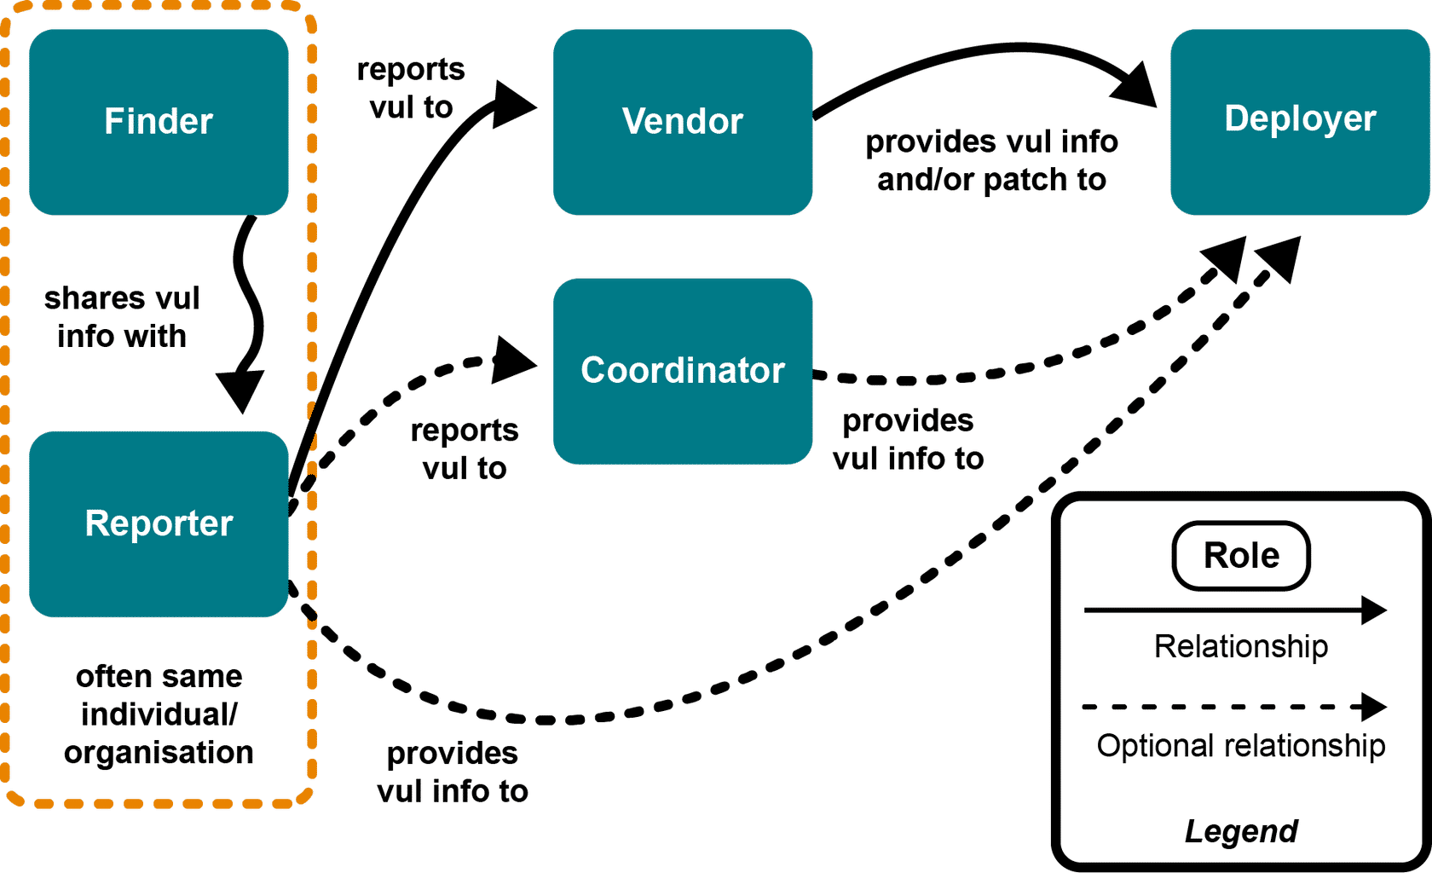
When a vulnerability is discovered, the finder (or another representative from that organisation) will contact the vendor. The vendor may already be aware, either through their own testing or via contact from other users. The vendor will validate the report and prioritise it based on several factors including workload and often a risk assessment tool. A remediation plan is created (which may or may not include a patch) and the vulnerability and associated plan are made known to the general public – often via inclusion in a vulnerability database such as the one managed by NIST (National Institute of Standards and Technology). It will be given an identifier such as the Common Vulnerabilities and Exposures ID (CVE-ID). Subsequently, the remediation is actioned or deployed, depending on whether it's a workaround or patch.

However, although technical vulnerabilities are an increasingly important aspect of what comprises a system's attack surface, it is by no means the only factor. There are several other areas that play an important role in the overall security of an asset. These are listed in the table provided which details the area of vulnerability, the process that manages the vulnerability and the associated risk.
Vulnerable Area | Managing Process | Risk
Processes | QA | Who audits the auditor?
People | HR | Checks carried out?
Technology | Purchasing, maintenance | Zero-day exploits
Buildings | Security (Traditional) | People
Cryptography | CVE, Research | Tech & testing

Processes
–
These areas include the processes themselves (which need to be checked and approved as part of a quality assurance process). The risk is that any process, including the QA process, is only as secure as the individual or entity doing the auditing.

People
–
Another area is people, these should be validated by HR as part of the hiring process however the risk is that the HR process is not followed (I have personal experience of such processes not being executed).

Technology
–
As discussed above, technology is a major contributor to any attack surface. It should be managed by both the purchasing process checking on vendors and product suitability/ certifications, as well as by regular maintenance activities such as patching and updates. The main risk, apart from failure of the mentioned processes, is the occurrence of a zero-day exploit where a vulnerability is discovered and exploited often before the vendor is aware, certainly before any mitigation exists.

Buildings
–
An often-overlooked vulnerability concerns buildings. Even in our modern world of cloud-based systems, the reality is that if someone gains access to a main office or secure area they often can more easily get access to secure systems. Physical security is still the domain of traditional security personnel and is one of the areas where people are still the weakest link.

Cryptography
–
Finally, cryptography is an often-overlooked vulnerability, but there are many areas that can be exploited. For example, does the system use the latest algorithms or is it using an encryption algorithm that has already been compromised? If the encryption is part of another product there is a reliance on the third party to ensure that the algorithm is strong enough. Regular checks on cybersecurity resources plus vulnerability databases will help. The other issue is the strength of the password or key used – brute force cracking used to be relatively low risk but recent hardware advances mean that previously strong passwords (e.g. 10 – 12 characters using 3 different character types) can now be cracked by brute force attacks in days, and sometimes hours.

Security Standards, Principles and Best Practice

One of the roles of the vulnerability assessor/'pen tester' is to advise their client on best practice settings for their website or application. Even though they were published almost half a century ago, the principles in Saltzer and Schroeder's (1975) paper - "The Protection of Information in Computer Systems" - are still valid today.
A summary of them is given below. The principles need to be interpreted to be applicable to modern systems, and some typical interpretations are given below.

Saltzer and Schroeder: Principles for the Protection of Data

Principal 1: Economy of Mechanism e.g., simple design
The first principle – economy of mechanism – is similar to Antoine de Saint-Exupery's quote about perfection. For example, some people will use multiple back-to-back firewalls, sometimes from different vendors, in order to make a system more secure. This is listed as an anti-pattern by the NCSC (2019) because it increases complexity, maintenance and management overhead for little or no security benefit, as well as making attacks and weaknesses much more difficult to detect. It also breaks the first 'best practice' principle.

Principal 2- Least Privilege e.g., sudo or UAC
The second principle – least privilege - is well understood and embraced. For example, Microsoft in their latest desktop OSes set the default user to NOT be the administrator. (This has been enshrined in Unix-like operating systems for many years with the "sudo" command giving the user temporary 'root' privileges).

Principal 3 - Open Design e.g. not security through obscurity
The third principle – open design – is related to the first in that it recommends that security controls are obvious and well documented, rather than attempting to complicate a system in an attempt to achieve 'security through obscurity'. The reality is the latter rarely works in practice, but it does make attacks and/or attackers much harder to find. The security policy should be separated from the security mechanism.

Principal 4 - Fail-safe Defaults e.g. deny first -do not run unnecessary services
The fourth principle – fail-safe defaults – basically says "lock everything down". That is, do not run services that are not explicitly required, close ALL unnecessary network ports and create the minimum number of users possible. Only install a service, add a user or open a port if it is explicitly required by the system or application. In addition, if a service or system fails, it should fail safely – which often means closed or not active.

Principal 5 - Separation of Privilege e.g., 2FA
The fifth principle – separation of privilege – is related to principle 2, but it says as well as using the least privilege levels possible, you should also aim to enforce those privileges through multi-factor authentication, such as using a password and an external token.

Principal 6 - The Least Common Mechanism e.g. avoid shared resources, also known as defence in depth
The sixth principle – the least common mechanism – recommends the use of security tiers and partitioning functions between tiers. For example, an application server, database server, and cache should all run in separate zones, ideally on separate virtual machines or even physical ones.

Principal 7 - Complete Mediation e.g., ACL checks at regular intervals
The seventh principle – complete mediation – recommends the use of a service (or daemon) that regularly checks the status of key files for evidence of tampering. Such services are referred to as intrusion detection systems (or IDS). In addition, it must also maintain active lists of authorised users so that if permissions have been revoked, the system is notified and updated immediately.

Principal 8 - Psychological Acceptability also known as least astonishment
The eighth principle – psychological acceptability – is a less obvious principle. It is concerned with the effect that security mechanisms and controls may have on the average user. For example, if utilising a security control is too onerous, users may try to circumvent the controls or stop using the system altogether. A common example is passwords – if the system requires that passwords are too complex, users may try and reduce the cognitive load by writing down passwords. This obviously bypasses the security control, especially if the written passwords are kept in plain sight such as stuck onto system screens and suchlike.

Principal 9 - Work Factor e.g. longer passwords, 256 bit keys, etc.
The ninth principle – work factor – is often related to the eighth principle above. As the authors assert "work factor is concerned with the cost of circumventing a security control" (Saltzer & Schroeder, 1975). A commonly quoted example concerns password complexity – simple 4-character alphanumeric passwords have only 26^4 = 456 976 combinations, which can be cracked by a modern computer in seconds. Thus, more complex passwords are obviously required but there is a trade-off required with psychological acceptability as discussed previously. Modern approaches include the use of passphrases instead of passwords, and using multi-factor authentication, as also discussed previously. There are alternatives to help manage more complex passwords, such as password managers.

Principal 10 - Compromise Recordings e.g., auditing and logging – includes continuous improvement
The tenth and final principle is compromise recordings which is the principle of recording access and changes to a system. This is a well-known and supported approach in modern systems, performed by modern logging and auditing solutions.
What “Compromise Recordings” Means
It refers to keeping detailed records of:
- Who accessed the system
- What actions they performed
- What changes were made
- When those actions occurred
This is done through logging and auditing tools.
The goal is to ensure that if a system is compromised—or if something suspicious happens—you have a reliable record to trace what occurred.
Although these principles may seem intuitive, research by Palo Alto networks around cloud systems (Chiodi, 2020) revealed nearly 200,000 infrastructure as code (IAC) templates with some form of security vulnerability, and these are the templates used to build the cloud systems that most organisations use on a daily basis.

List of Principles from Salter and Schroeder 1975
• Summary of the Principles:

Summary
Economy of Mechanism
Keep security designs simple and minimal—complex systems are harder to manage and easier to break.
• Least Privilege
Give users and processes only the permissions they absolutely need, and nothing more.
• Open Design
Security should rely on strong design, not secrecy—controls should be open, clear, and well documented.
• Fail-safe Defaults
Deny by default—only allow services, users, and ports when they are explicitly required.
• Separation of Privilege
Protect sensitive actions using multiple independent checks, like passwords plus 2FA.
• Least Common Mechanism (Defense in Depth)
Separate systems and resources so one compromise doesn’t expose everything.
• Complete Mediation
Check access every time, not just once—permissions and integrity must be continuously verified.
• Psychological Acceptability (Least Astonishment)
Security must be usable, or users will bypass it and weaken protection.
• Work Factor
Make attacks expensive and time-consuming, while balancing usability (e.g., long passphrases).
• Compromise Recordings
Log and audit everything important so incidents can be detected, traced, and improved upon.

In addition to the basic principles discussed above, many systems may need additional principles to be applied, depending on the legal regulations or standards that are enforced by the hosting region.
For example, most countries will require an e-commerce site to comply with the Payment Card Industry Data Security Standard (PCI-DSS); in North America, health sites would need to comply with the Health Insurance Portability and Accountability Act (HIPAA), whereas sites storing data in Europe, or about European citizens would need to comply with the General Data Protection Regulation (GDPR).

Global Law.png
There are still other regulations from the International Organisation for Standardisation (ISO) and the National Institute of Standards and Technology (NIST) that may also apply.

Deployment Blueprint
Deployment Blueprints
The range of deployment systems and solutions has increased almost exponentially since the end of
the 20th Century or, in reality, since the advent of the World Wide Web. Pre 1990s, most enterprise
computer systems were housed in dedicated data centres and accessed over private networks and
leased lines. After the advent of the web, there was a surge in businesses looking to acquire a web
presence, firstly as a shop window but increasingly to provide access for a progressively mobile and
distributed workforce. In addition, post Web 2.0 (O'Reilly, 2005) there was a preponderance of web
based businesses such as Flickr, Napster, and Facebook, amongst many others, seeking to build
and commercialise 'the web as a platform' (O'Reilly, 2005). Although some of these companies have
since fallen by the wayside, others (such as Facebook) have built a multi-billion-dollar empire based on
their web platform.
In 2022, several trends can be identified as the blueprints for enterprise systems. The first major trend
is the move from private data centres or on-premise hosting to cloud-based systems, especially public
cloud systems. In many ways, the public cloud has been the computing success story of the 21st
Century. For example, AWS alone generated over $60 Billion of revenue for Amazon in 2021, its
largest single revenue contributor (although not its most profitable) (Goldberg, 2022). Cloud systems
can be based on several models and the most straightforward is IaaS (Infrastructure as a Service)
which is where cloud providers supply virtual machines while the clients provide (and manage) the OS,
applications and data. This was the first service offered by suppliers and historically many clients
migrated on-premise virtual images directly to the cloud, with little or no changes – a process known as
'lift and shift'. More recently, cloud providers offered (and promoted) PaaS (platform as a service) where
the client only needed to supply the application (or even just the application code) and data. This is a
far more 'cloud native' method of deployment. However, it often requires more of a transformation of the
on-premise application. There is also the option of SaaS (software as a service) where the cloud
provider manages the whole stack, even to the point of managing, storing and backing up the data. The
relationship between these models is shown in the diagram.
The major reasons that enterprises have migrated their workloads to the cloud are the often-quoted
flexibility, reliability, security and cost benefits (Deckler, 2016). Which of these benefits are available,
and to what degree, depends to a large extent on how the migration of the workloads is carried out, and
what transformations have taken place. As discussed previously, all workloads in the cloud
are virtualised. However, this can take the form of hardware virtualisation – where migrated workloads
run inside individual virtual machines; or operating system virtualisation where migrated workloads run
inside containers which are more efficient (although arguably less secure) than traditional virtual
machines.
Although cloud providers often promote their solutions as being more secure than more traditional on
premise systems, this is very dependent on the security measures and processes adopted by the client.
As discussed previously, research by Palo Alto Networks (Chiodi, 2020) revealed that almost 200,000
cloud templates had security errors and/or omissions. In addition, it is important that the principles
discussed previously are adhered to during the design and/or transformation process. Designers and
authors should also pay attention to the repositories used, in particular, to ensure that no password files
or records of other secrets are stored therein. A useful tool is Shhgit which, as the author explains, "can
work in two ways: consuming the public APIs of GitHub, Gist, GitLab and BitBucket or by processing
files in a local directory" (Price, 2021). The tool is used to scan files looking for API passwords, tokens,
keys and/or other secrets that are accidentally stored in public repositories. In addition, there are other
tools, such as those produced by Rhino Security Labs or Cyberark, that can be used to search AWS for
shadow admin permissions - an often undiscussed aspect where created roles can acquire unexpected
or unpredicted admin-like permissions (Valeiras, 2021).
Another benefit of cloud-hosted applications is the provision of edge servers (An edge server is a server placed close to the end user (at the “edge” of the network) instead of far away in a central data centre. An edge server brings data and processing closer to users so services are faster, safer, and more efficient.)and computers, which are
used to create a Content Delivery Network (CDN). CDNs are often used to help prevent denial of
service (DoS) or Distributed Denial of Service (DDoS) attacks as well as accelerating access to certain
types of web content. This is accomplished by caching web content in multiple servers located
worldwide (Nygren et al, 2010). Increasingly, many larger web hosting companies also offer CDN
protection for their hosted websites.
Many smaller companies, often referred to as SMEs (small/ medium enterprises) are also looking to
acquire a web presence. However, unlike larger enterprises, many SMEs may not be natively digital
businesses or even open to the digitalisation process (Kantar, 2019). Those SMEs who do decide
to digitalise or even automate their business often utilise smaller external web designers or consultants,
rather than the larger cloud providers. One of the ways that smaller businesses acquire a web presence
is via the use of pre-packaged solutions, such as those provided by softaculous (softaculous.com,
2022). Although this provides easy to deploy, configure and use applications care should be taken
around updates and the good practice principles discussed previously should still be
applied. Softaculous applications can be deployed on dedicated, stand-alone IP addresses but far more
commonly they are deployed on shared-IP hosting sites, where the IP is shared between multiple
applications and the sites are differentiated via webserver rules. In short:
SMEs choose simple, low-cost web solutions, but they must still manage updates and security properly—especially when using shared hosting.
The recent Covid epidemic, and its
effect on the increase in home and remote working, has resulted in many SMEs increasing their web
presence and actively pursuing a digital strategy.
Software Virtualization (OS-level / Containers)
- Uses containers that share the host operating system
- No full OS per application
- Managed by tools like Docker or Kubernetes
- Faster and more efficient, but slightly less isolated
- Uses fewer resources
Example: Running multiple Docker containers on one Linux server.
Hardware Virtualization
- Uses virtual machines (VMs) that emulate physical hardware
- Each VM runs its own operating system
- Managed by a hypervisor (e.g., VMware, Hyper-V)
- More isolated and secure, but heavier
- Uses more resources (CPU, memory)
Example: Running Windows and Linux as separate VMs on one physical server.

Cyber Kill Chain
An often-recommended strategy is to think like an attacker when trying to establish the best defence for a system. Similarly, one of the aspects of the vulnerability assessment process is to try and compromise a client's system. Lockheed Martin is a well-known military and commercial enterprise contractor and they produced (and documented) a 'penetration-testing’ approach known as the Cyber Kill Chain.
As the author states:
"this paper presents a new kill chain model, one specifically for intrusions. The essence of an intrusion is that the aggressor must develop a payload to breach a trusted boundary, establish a presence inside a trusted environment, and from that presence, take actions towards their objectives, be they moving laterally inside the environment or violating the confidentiality, integrity, or availability of a system in the environment."
(Hutchins et al, 2011)
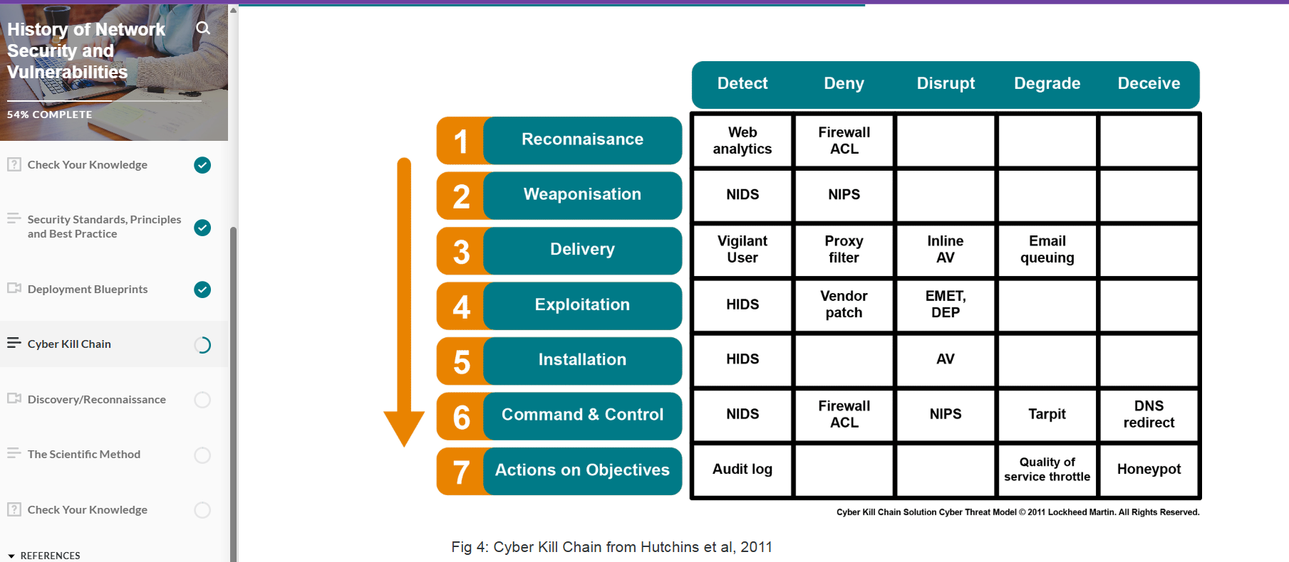
"this paper presents a new kill chain model, one specifically for intrusions. The essence of an intrusion is that the aggressor must develop a payload to breach a trusted boundary, establish a presence inside a trusted environment, and from that presence, take actions towards their objectives, be they moving laterally inside the environment or violating the confidentiality, integrity, or availability of a system in the environment."
(Hutchins et al, 2011)
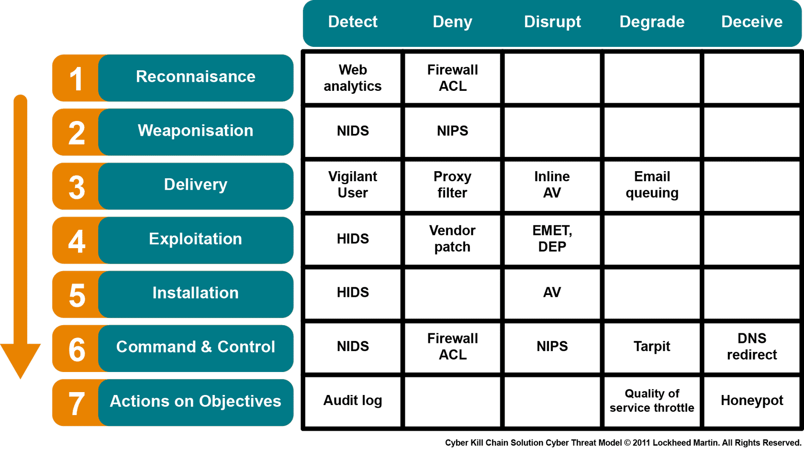
Fig 4: Cyber Kill Chain from Hutchins et al, 2011
In addition, the paper presents an approach to develop the kill chain, as shown in the diagram. Each step is discussed below.
Reconnaissance: or discovery involves research to find employee contact details, email addresses and similar personal information that can be exploited.
Weaponisation: is the creation of a software artifact- often referred to as a ‘payload’-that can be delivered to target website or application and used to create a ‘backdoor’ that is an unexpected entry point into the site. The payload can be created using a weaponiser (an automated tool designed to create such payloads) or more simply as a VBA (A VBA script is code written in Visual Basic for Applications (VBA), a programming language created by Microsoft.
Simple explanation:
VBA is used to automate tasks and add custom features inside Microsoft Office programs. )Script embedded in a Microsoft document or even an executable file embedded in a pdf file.
Delivery
Delivery, as the name suggests, is concern with transporting the payload to its target. The most common transport are: email attachments, website download and USB removal media.
Exploitation
Exploitation is the method to trigger the execution of the code. This may be encrypting user’s asset, exploiting OS or a middleware vulnerability as part of a ransomware attack.
Installation
Installation involves making the payload a persistent presence on the host machine where it may create more exploitation or even spread to other users’ systems.
Command and Control (C2)
C2 is the real indicator of an Advanced Persistent Threat (APT). C2 gives the third party access to a compromised host from which they can extract information, infect other connected systems or even use the infected host as a jump point to infect other machines.
Actions on Objectives
Where the compromised system is used by third parties may for several months or more. SolarWinds breach which illustrates many of these steps.

Discovery
Even if you are not planning to create and deliver an APT, every vulnerability assessment (or pen-test) should start with a discovery phase. Historically 'social engineering' required that someone needed to get a list of staff employed by the client, and often send spoofed emails or even make phone calls posing as members of the support team. Nowadays personal information discovery (PID) is much easier thanks to social media. People seem happy to give up huge amounts of personal and confidential information (via social media sites) for no payment whatsoever, making the social engineer's job much easier. As well as easy access once registered on the sites in question, there are a number of search engines that can be used to gather and analyse social media information as well. The next stage of discovery is to find out as much information as possible about the target website. This is a literature search as opposed to a scanning of the site (which will occur in a later phase). The search should include the type and version of the operating system, middleware, and applications deployed. This information can be obtained from system designs and documentation. Once a list of software deployed with versions has been created, then the investigator should consult vulnerability databases (such as the National Vulnerability Database (CVSS/NVD)) to find any vulnerabilities listed for the software in question. We will discuss these steps in more detail in the next unit.

The scientific Method
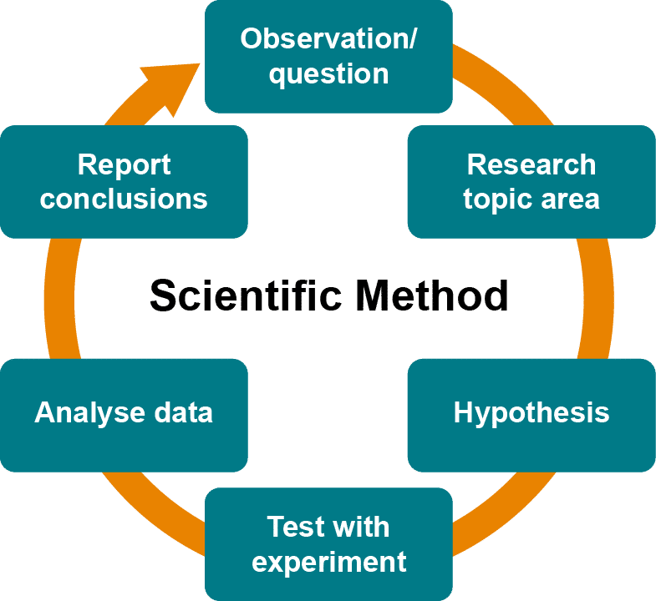
The scientific method is the classical approach to problem-solving in many scientific disciplines – including physics, mathematics, and of course computer science.
It was first postulated (FARZSHODEH) by Aristotle (Poppi, 2004) as a form of empirical investigation, but it has been reiterated, reused, and in some cases 'rediscovered' by many philosophers throughout the ages. So much so that it is widely applicable to many domains and sub-domains.

Modelling
For example, it can be applied to modelling when the hypothesis may form the basis of the model or concept to be investigated.

Engineering
In engineering, it may be the basis of a technique to improve a process or reduce cost.

Cyber Security
–
In cyber security, it may be used as the basis of a penetration test – where the hypothesis may be as simple as "this system is secure" and then vulnerability testing tools are used to disprove (or falsify) the hypothesis.

The basic approach consists of a number of principles:
- 1
1
Firstly the use of observation to raise questions about the subject under investigation.
- 2
2
Secondly research to establish ground rules and basic concepts.
- 3
3
Thirdly the formulation of a hypothesis to prove (or disprove).
- 4
4
Fourthly a test phase where the hypothesis is tested.
- 5
5
Fifthly the analysis of the data – is the hypothesis supported or falsified.
- 6
6
Sixthly report findings and conclusions and suggest next steps or further work required

